Creating a new VS Code Project
Last Updated 2/12/2026
By Bryan A. “CrazyUncleBurton” Thompson
Batee2@gmail.com or bryan@batee.com or (573) 647-5301

Install VS Code
- Browse to: https://code.visualstudio.com/download#
- Download the VS Code for your OS. For Windows, use the one marked System instead of the one marked User and instead of the Windows Store version. It will install for all users and give you the ability to edit important files.
- Right-click the file you downloaded and choose “Run As Administrator”.
- Give the popup window permission.
- Accept the license agreement.
- Choose the default location to install VSCode.
- Click the Create a Desktop Icon and “Open with Code” options, then click Next and then Install.
- Leave “Launch Visual Studio Code” checked and then click Finish.

Configure Github User Info in VS Code
- Start a terminal by clicking Terminal/New Terminal from the menu.
- Issue this command, replacing “Your Name” with your Github User Name: git config --global user.name "Your Name"
- Issue this command, replacing your.email@example.com with your actual email address: git config --global user.email your.email@example.com
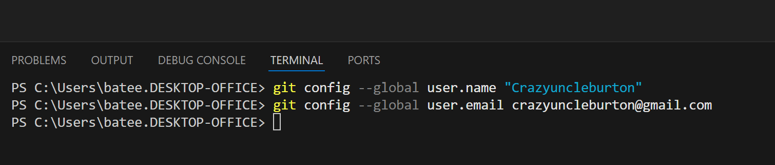
- Restart the VS Code app.

Install the PlatformIO Extension in VS Code
- Open VS Code
- Click Extensions (left hand toolbar) 
- Search “PlatformIO”
- Install PlatformIO
- Trust PlatformIO if needed

Install the MS C/C++ Compiler Extension in VS Code
- Open VS Code
- Click Extensions (left hand toolbar): 
- Search “C/C++”
- Install the Microsoft C/C++ Extension.
- It’s Microsoft, so no trust needed.

Create a PlatformIO Project in VS Code
- Click the alien head / PlatformIO logo  from the left hand toolbar.
- From the Quick Access menu (bottom left), choose “Projects & Configuration”.
- Click the “+ Create New Project” button.
- Choose a name. Choose anything. This is temporary. The project name will be chosen later.
- Choose the board from the list. In our case, the board is an M5Stack Core2.
- Choose the Framework “Arduino”.
- Check the box that says “Location: Use Default Location”. This directory is “<UserProfile>\Documents\PlatformIO”.
- Click the Finish button and let it build the project.
- Close the temporary project by choosing File/Close Folder.
- One Time Per Machine: Browse to “<UserProfile>\Documents\PlatformIO” and in that folder create the folder “Projects”.

Create a Project in Github
- Go to Github.com and login with the userID of the person where the project will be stored.
- Choose Repositories from the top menu.
- Click New.
- Give the repository a name. Note if the name contains spaces, Github will change the name of the project. I chose the name “M5Stack-Testing”.
- Enter a description like “M5Stack Testing and Stuff”.
- Set visibility to Private so we aren’t republishing the code we’re learning with.
- Change the Add README slider to On.
- Click the green Create Repository button.

Synch Github Project to Local Machine
- From the page Github creates for the repository, click the green “<> Code” button.
- Copy the URL of the project to the clipboard.
- In VS Code, make sure there is not currently a project open.
- Click the alien head / PlatformIO logo in the left menu bar.
- From the Quick Access menu, click “Clone Git Project”.
- Paste the project URL on the clipboard to the field at the top of the VS Code project using CTRL-V and then press Enter.
- A dialog opens. It’s asking where you want to put the local copy of the repository. The answer is always “<UserProfile>\Documents\PlatformIO\Projects”. DO NOT browse into the Projects folder and then click OK. Rather highlight the Projects folder and click OK.
- A folder named with the project name will be created in the folder “UserProfile>\Documents\PlatformIO\Projects”.
- When the repository in Github has been cloned to the local machine, VS Code will prompt you to open the project. Always choose “In A New Window” as we don’t know what changes have been made to the current window.

Add Files to Local Project
- Go to the temporary project folder that PlatformIO created for us. <UserProfile>\Documents\PlatformIO\Projects\Temporary
- Copy all the files in that project to the clipboard using CTRL-C
- Go to the folder that PlatformIO created for the Github-linked project and paste them using CTRL-V.

Upload the Project to Github
- In VS Code, click the Source Control icon 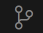 from the left hand toolbar.
- We see a list of files which have been added/removed/changed since the last time we synched with Github.
- Click the “(checkmark) Commit” blue button at the top left under Changes.
- We get a “There are no staged changes to commit” message. Click Yes to stage all changes to commit.
- A file called “COMMIT_EDITMSG” is created. It’s asking us to tell Github what we did this time. Type “Added Initial Project Files” to the first line.
- Close this file by clicking on the Dot / X in the upper RH corner of the file name at the top of the file.
- Yes to Save.
- A blue “Sync Changes” button appears in the top left corner of the Changes window. Click it to sync with Github.
- A message appears about pushing and pulling from Github. Click Yes.A\
- A new entry should appear in the GRAPH pane below the Changes pane, showing the commit we just made.
- Go to the Github page for the repository we just created and refresh that page in the web browser.
- We should see the folder structure of our project, along with the platformio.ini file that tells PlatformIO how to compile our project.
- Do we want VS Code to run git fetch periodically? Only really needed if someone else is working on the project with us, so let’s say no to avoid confusion.

Add Our Source to the Project
- Go back to VS Code. Click the Explorer icon  at the top left of the left toolbar. This shows us the files in the local project.
- We have a sample main.cpp file. That file contains some sample code we don’t need, so highlight it and delete it.
- Go to the URL of the project that we want to copy. M5Stack gives us some sample code for everything they sell: https://github.com/m5stack/M5Unit-ENV/blob/master/examples/Unit_ENVIII_M5Core2/Unit_ENVIII_M5Core2.ino
- Their Github page opens and we see a sample Arduino project with the .ino file naming. Highlight the code in that file and copy it to the clipboard.
- Paste the clipboard contents to the main.coo file and save it.

Adding Libraries to the Project
- Click the PlatformIO icon  in the left toolbar and select Libraries from the Quick Access pane.
- We see from the main.cpp file that we are looking for M5Unified and M5UnitENV.
- Type “M5Unified” into the search bar and click the search icon. A list appears.
- Select “M5Unified by M5Stack…” and click it to browse to that library.
- Click the “Add to Project” button
- Select our project from the list and click “Add” to download it to the .pio\libdeps folder.
- Add the “M5UnitENV” library to the project the same way we did for M5Unified.
- If a library is not available via the PlatformIO download, you can manually add that library to the /lib folder.

Building The Project
- Go to VS Code and click the Check Mark icon in the bottom toolbar. The hover text will be PlatformIO: Build
- The project should build without error.

Uploading To Microcontroller
- Connect a USB cable from the computer that VS Code is running on to the M5Stack microcontroller.
- Connect a cable from the red port on the microcontroller to the red port on the ENV III sensor.
- In VS Code, look at the bottom toolbar for the COM port icon 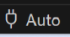 with hover text “set upload/monitor/test port” and click it.
- See if the device is present in the list that appears in the top center of VS Code. It should say Silicon Labs CP210x with some randomly assigned COM port that isn’t in use by anything else. Don’t choose the Silicon Labs line – leave it set to Auto. Plugging the microcontroller into a different port can cause the COMxx number to change for the microcontroller.
- In VS Code, click the PlatformIO Upload icon in the bottom toolbar. The hover text will be PlatformIO: Upload
- The project will compile again. Since there are no changes, it should compile much faster than the original compile took.
- When it’s ready to upload, we see lines like “Connecting…” and “Writing…”. Wait for the line that says SUCCESS in green text before proceeding.
- When finished, the microcontroller will reboot.
- Nothing will appear on the screen. That’s normal, as it is not designed to print anything to the screen. The data it’s producing is being sent to the serial monitor. To see it, from the bottom toolbar click the PlatformIO: Serial Monitor icon 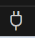 with the hover text marked “PlatformIO: Serial Monitor”.
- We see garbage data because the serial speed that the microcontroller is outputting is not what PlatformIO is configured for: �␜��J��1��1!���!�J�!
- Click the Explorer icon  at the top left toolbar and open the platformio.ini file.
- Add this line to the bottom of the platformio.ini file: monitor_speed = 115200
- Save the platformio.ini file.
- We need to kill the serial monitor task that’s still running before we can program again. To the right of the terminal window, click the trash can icon next to the Monitor task.
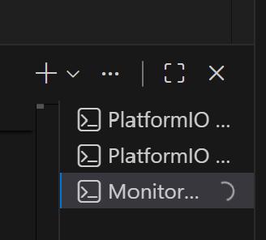

- Click the Upload icon 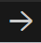 (bottom toolbar, hovertext PlatformIO: Upload) again.
- We can read the text, but it’s not outputting any sensor data.

What Happens When It Doesn’t Work?
- I looked at this for an hour.
  - Checked to be sure we had the sensor connected to the I2C bus specified in the project. Not it.
  - Disassembled microcontroller and removed base in case there were bus contentions. Not it. Put it back together.
  - Added Arduino library. Not it. Removed.
  - Added M5.update(). Not it. Removed.
- Looked at a sample working program. It looks like how serial is enabled has changed. I replaced the M5.begin(); line with these three lines.
  - auto cfg = M5.config();
  - cfg.serial_baudrate = 115200; // This both enables Serial Port 1 and configures the speed of that port
  - M5.begin(cfg);
- Now we see packets of data every second containing temperature, humidity, another sensor’s temp, air pressure and guess at our altitude!
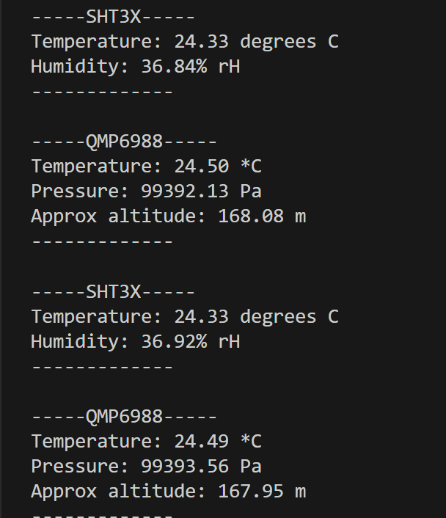
- I left in the above troubleshooting because this is what happens in the real world. If it doesn’t work the way they say, compare the current project to a working one with similar functionality and make the nonworking program like the working program.

Re-Synch with Github
- Now that it works, let’s sync it to Github to preserve it and share it with others.
- Click the Source Control icon in the lefthand toolbar of VS Code.
- Click Commit, then Yes, add a comment in the comment file about what we did: “We added sensor reading code to main.cpp”.
- Close the comment file.
- Click the “Sync Changes” button.
- Click Yes. Our changes have been uploaded to Github and Githib now has a working project.
- Check your work by going to Github and selecting our repository and then looking at the contents of main.cpp. If it contains “Serial.begin…” the project has been uploaded to Github!
- If it works, consider adding some info (in Markdown form) to the README.md file and sharing it with the world by enabling Public mode in the Github project settings.

If It Still Doesn’t Work
- Here is a link to a project that works. Download it and extract to a local folder and open that folder in VS Code: https://github.com/CrazyUncleBurton/M5Stack-Testing
- Another way we could have solved this is with AI.
- Go to Extensions and install “Github Copilot Chat”.
- Go to the right-hand pane of VS Code.
- At the bottom, set it to Agent mode and set the Agent to “Auto”.
- Type your question into the grey box at the bottom of the right-hand pane.

Info About the M5Stack Stuff
If you orient the controller with the row of soft buttons at the bottom of the screen, the reset button is on the bottom of the controller, and the on/off switch is on the left of the controller. To turn it on, press and release the button on the left. To turn it off, press and hold the button on the left for about five seconds. To reset it, press and release the button on the bottom.
The microcontroller comes with an Allen key that fits the screws on the device. Be aware that there are two length screws, and if you put the wrong screw in the wrong hole, the screen will crack. The short screws go in the back top holes. The long screws go in the back bottom holes. Again, the bottom is the side near the reset switch.
There is a huge amount of info about the microcontroller here: https://shop.m5stack.com/products/m5stack-core2-esp32-iot-development-kit-for-aws-iot-edukit
And here: https://docs.m5stack.com/en/core/core2_for_aws
Their Github for everything M5Stack is here: https://github.com/m5stack

